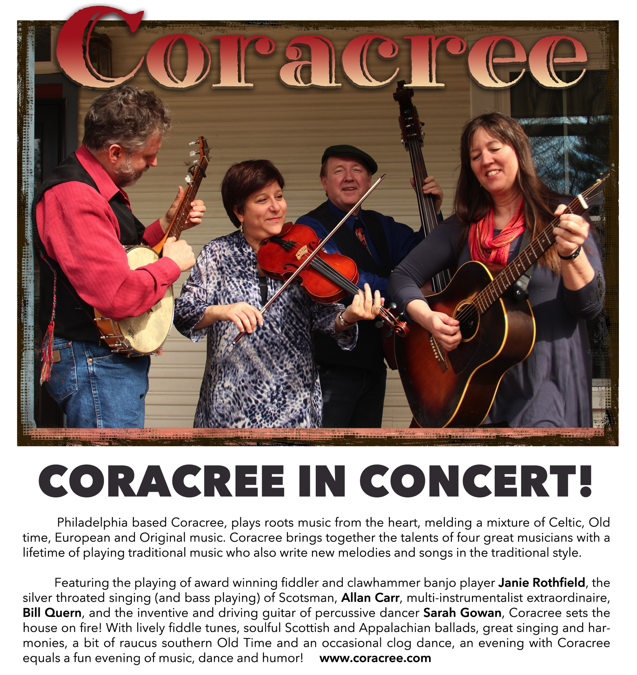

Concert - Day Date,  0:00 pm

**address**

directions

**Admission:  by donation -**  suggested $15

Please contact name at [**email**](mailto:maxine.louie@gmail.com) for more information

**www.coracree.com**